

**Food Bucket**

**Software Project -1**

**Submitted by**

|  |  |
| --- | --- |
| **Name** | **ID** |
| **Rahman, Md.Zahid** | **15-28982-1** |
| **Bhattacharjee, Susmoy** | **15-28966-1** |
| **Md. Hasan, Khondoker** | **15-29388-1** |
| **Hasan, Md Ariful** | **15-29287-1** |

**Under the Supervision of**

**Mohaimen-Bin-Noor**

**Lecturer**

**Department of Computer Science**

**American International University – Bangladesh**

**Date of Submission: 27 August, 2018**

**DECLARATION**

This is to certify that this project is our original work. No part of this work has been submitted elsewhere partially or fully for the award of any other degree or diploma. Any material reported in this project has been properly acknowledged.

|  |  |  |  |
| --- | --- | --- | --- |
| **RAHMAN, MD.ZAHID**  15-28982-1  SE |  |  | **BHATTACHARJEE, SUSMOY**  15-28966-1  SE |
|  |  |  |  |
| **MD. HASAN, KHONDOKER**  15-29388-1  CSSE |  |  | **HASAN, MD ARIFUL**  15-29287-1  CSSE |

APPROVAL

The project titled “**Food Bucket**” has been submitted to the following respected members of the board of examiners of the Department of Computer Science, American International University – Bangladesh [AIUB] in partial fulfilment of the requirements for the degree of Bachelor of Science in Computer Science and Software Engineering / Bachelor of Science in Software Engineering on August 27, 2018 and has been accepted as satisfactory.

|  |  |  |  |  |  |
| --- | --- | --- | --- | --- | --- |
| **MOHAIMEN-BIN-NOOR**  Lecturer  Department of Computer Science  Faculty of Science & IT  AIUB | |  |  | **MD. AL-AMIN**  Lecturer  Department of Computer Science  Faculty of Science & IT  AIUB | |
|  | |  |  |  | |
| **DR. DIP NANDI**  Associate Professor and Head [UG Program]  Department of Computer Science  Faculty of Science & IT  AIUB | |  |  | **PROF. DR. TAFAZZAL HOSSAIN**  Pro-Vice Chancellor and  Dean  Faculty of Science & IT  AIUB | |
|  | | | | | |
|  | **DR. CARMEN Z. LAMAGNA**  Vice Chancellor  AIUB | | | |  |

ACKNOWLEDGEMENT

This project is the result of our cordial effort and our supervisor’s initiative and constant motivation. But first of all we would like to be grateful to the Almighty ALLAH, Who gives us the effort to work on this project. Special thanks goes to our honorable supervisor Mohaimen-Bin-Noor, Lecturer, American International University – Bangladesh [AIUB]. His excellent supervision and constant support makes this project possible. We also want to thank our Vice Chancellor Dr. Carmen Z. Lamagna, our Dean Prof. Dr. Tafazzal Hossain, our Associate Dean-In-Charge, Mr. Mashiour Rahman, and our Head of Department Dr. Dip Nandi for their constant motivation and support.

**TABLE OF CONTENT**

|  |  |  |
| --- | --- | --- |
|  | Project Summary………………………………………………………………... | 8 |
| 1 | INTRODUCTION ……………………………………………………………... | 9 |
| 1.1 | Purpose………………………………………………………………………….. | 9 |
| 1.2 | Background To The Problems …………………………………………………. | 9 |
| 1.3 | Project Scope …………………………………………………………………… | 9 |
| 1.4 | Intended Audience And Reading Suggestions …………………………………. | 10 |
| 2 | EXISTING APPLICATION / SYSTEM STUDY ……………………………... | 11 |
| 2.1 | List Of Domestic Applications / Systems ……………………………………… | 11 |
| 2.2 | List Of International Applications / Systems …………………………………... | 11 |
| 2.3 | Features In Existing Applications / Systems …………………………………… | 11 |
| 2.4 | Features In Domestic Applications …………………………………………….. | 13 |
| 2.5 | Features In International Applications …………………………………………. | 14 |
| 3 | REQUIREMENT SPECIFICATIONS ………………………………………… | 16 |
| 3.1 | Application Perspective ………………………………………………………... | 16 |
| 3.2 | Application Features …………………………………………………………… | 16 |
| 3.3 | User Characteristics ……………………………………………………………. | 17 |
| 3.4 | Requirements For End User ……………………………………………………. | 17 |
| 3.4.1 | Requirements For Unregistered Users …………………………………………. | 17 |
| 3.4.2 | Requirements For Registered Users (Foodies) ………………………………… | 18 |
| 3.4.3 | Requirements For Restaurant Owners …………………………………………. | 18 |
| 3.4.4 | Requirements For Admins ……………………………………………………... | 19 |
| 3.5 | Operating Environment ………………………………………………………… | 19 |
| 3.6 | Design And Implementation Constraints ………………………………………. | 20 |
| 3.7 | User Documentation ……………………………………………………………. | 20 |
| 3.8 | Assumptions And Dependencies ……………………………………………….. | 21 |
| 4 | DESIGN SPECIFICATIONS ………………………………………………….. | 22 |
| 4.1 | User Scenario …………………………………………………………………... | 22 |
| 4.2 | UML Diagrams ………………………………………………………………… | 24 |
| 4.2.1 | Use Case Diagrams …………………………………………………………….. | 24 |
| 4.2.2 | Activity Diagrams ……………………………………………………………… | 25 |
| 4.2.3 | Entity Relation Diagram ……………………………………………………….. | 28 |
| 4.3 | Data Dictionary ………………………………………………………………… | 29 |
| 4.4 | User Interface Design …………………………………………………………... | 32 |
| 5 | FEATURES IMPLEMENTATIONS ………………………………………….. | 36 |
| 5.1 | Sign Up ………………………………………………………………………… | 36 |
| 5.2 | Login …………………………………………………………………………… | 36 |
| 5.3 | Change Password ………………………………………………………………. | 36 |
| 5.4 | Set Information ………………………………………………………………… | 36 |
| 5.5 | Search Method Selection ……………………………………………………….. | 36 |
| 5.6 | Modify Search ………………………………………………………………….. | 37 |
| 5.7 | Show Reviews ………………………………………………………………….. | 37 |
| 5.8 | Show And Post Reviews ……………………………………………………….. | 37 |
| 5.9 | Live Support ……………………………………………………………………. | 37 |
| 5.10 | Select Search Location …………………………………………………………. | 37 |
| 5.11 | Assign Own Food Rating ………………………………………………………. | 37 |
| 5.12 | Cuisines Selection For Restaurants …………………………………………….. | 38 |
| 5.13 | Modifying Account Information ……………………………………………….. | 38 |
| 5.14 | View Restaurant Information …………………………………………………... | 38 |
| 5.15 | Remove Account ……………………………………………………………….. | 38 |
| 5.16 | Uploading Pictures Of Foods …………………………………………………... | 38 |
| 5.17 | Delete Cuisines ………………………………………………………………… | 38 |
| 5.18 | Entering Food Item With Name Price And Description ……………………….. | 38 |
| 5.19 | One Tap Best Food Search ……………………………………………………... | 39 |
| 5.20 | Sort By Price …………………………………………………………………… | 39 |
| 5.21 | Sort By Restaurant Rating ……………………………………………………… | 39 |
| 5.22 | Sort By Food Rating …………………………………………………………… | 39 |
| 5.23 | Sort By Food Price ……………………………………………………………... | 39 |
| 5.24 | Update Food Name, Price And Description ……………………………………. | 39 |
| 5.25 | User And Restaurant Owner Can Sign Out …………………………………….. | 40 |
| 6 | SOFTWARE TESTING PLAN ………………………………………………... | 41 |
| 6.1 | System Testing …………………………………………………………………. | 41 |
| 6.2 | Regression Testing ……………………………………………………………... | 45 |
| 6.3 | Acceptance Testing …………………………………………………………….. | 46 |
| 7 | CONCLUSION ………………………………………………………………… | 50 |
| 7.1 | Future Work ……………………………………………………………………. | 50 |
| 7.2 | Contribution To The Society …………………………………………………… | 50 |
| 8 | REFERENCES …………………………………………………………………. | 51 |

**LIST OF TABLES**

|  |  |  |
| --- | --- | --- |
| Table – 1 | List Of Features ………………………………………………………….. | 12 |
| Table – 2 | List Of Features In Domestic Applications ……………………………… | 13 |
| Table – 3 | List Of Features In International Applications …………………………... | 14 |
| Table – 4 | User Story ………………………………………………………………... | 22 |
| Table – 5 | Image Gallery ……………………………………………………………. | 29 |
| Table – 6 | Restaurant ………………………………………………………………... | 29 |
| Table – 7 | Cuisine …………………………………………………………………… | 30 |
| Table – 8 | Selected Cuisine …………………………………………………………. | 30 |
| Table – 9 | Users ……………………………………………………………………... | 30 |
| Table – 10 | Food ……………………………………………………………………… | 30 |
| Table – 11 | Review Table …………………………………………………………….. | 31 |
| Table – 12 | Rating Table ……………………………………………………………… | 31 |
| Table – 13 | Foodies …………………………………………………………………… | 31 |
| Table – 14 | Food Rating Table ……………………………………………………….. | 32 |
| Table – 15 | System Testing …………………………………………………………… | 41 |
| Table – 16 | Regression Testing ……………………………………………………….. | 45 |
| Table – 17 | Acceptance Testing ………………………………………………………. | 46 |

**LIST OF FIGURES**

|  |  |  |
| --- | --- | --- |
| Figure 1 | Guest (Use Case) ………………………………………………………….. | 24 |
| Figure 2 | Foodies (Use Case) ……………………………………………………….. | 24 |
| Figure 3 | Restaurant Owner (Use Case) …………………………………………….. | 25 |
| Figure 4 | Login (Activity) …………………………………………………………... | 25 |
| Figure 5 | Searching (Activity) ………………………………………………………. | 26 |
| Figure 6 | Restaurant Account Sending Request (Activity) …………………………. | 26 |
| Figure 7 | User-Profile (Activity) ……………………………………………………. | 27 |
| Figure 8 | User-Report (Activity) ……………………………………………………. | 27 |
| Figure 9 | ER-Diagram ………………………………………………………………. | 28 |
| Figure 10 | App Launcher ……………………………………………………………... | 32 |
| Figure 11 | Map Activity ……………………………………………………………… | 32 |
| Figure 12 | Login Form ………………………………………………………………... | 33 |
| Figure 13 | Restaurant Dashboard …………………………………………………….. | 33 |
| Figure 14 | Restaurant View Profile …………………………………………………... | 33 |
| Figure 15 | Navigation Drawer For Restaurant Owner After Login ………………….. | 33 |
| Figure 16 | Searching Fields …………………………………………………………... | 34 |
| Figure 17 | All Cuisines With Total Restaurant ………………………………………. | 34 |
| Figure 18 | Uploading Picture For Restaurants ……………………………………….. | 34 |
| Figure 19 | Photo Gallery (Restaurant) ………………………………………………... | 34 |
| Figure 20 | Navigation Drawer For Foodies After Login ……………………………... | 35 |
| Figure 21 | Foodies Profile ……………………………………………………………. | 35 |
| Figure 22 | Apps Front View ………………………………………………………….. | 35 |
| Figure 23 | Searching Utilities ………………………………………………………… | 35 |

**PROJECT SUMMARY**

This project is based on food restaurant application which helps people to find the restaurants based on their needs. The system consists two parts basically: one mobile application and one web portal. In this system restaurant owners can provide their restaurant information using the web-portal. An authorized administration who can access the web portal can update the information of the web portal. On the other hand, the mobile application is used to provide locations of best restaurants for a specific food and view information about them. User can search their desired dishes through the mobile application. It is notify that in our system, only register users can rate the review. The application uses GPS connection also to fetch and display results and the users can view top desired restaurants on a map.

|  |
| --- |
| **CHAPTER 1** |
| **INTRODUCTION** |

The “Food Bucket” is a food and restaurant finding based application. We are doing this application for the people to find any kind of food based on their needs. People needn’t worry about to find restaurant or food. This application will help people based on the specification like dish, cuisine, restaurant and user’s current position. The application is free to download, this is also one of the benefit to the user. The restaurant information will be displayed to the user on the basis of user’s reviews and points

**1.1 Purpose**

The purpose of this document is to give a detailed description of the “Food Bucket” application. It will illustrate the purpose and complete declaration for the development of system. It will also explain system constraints, interface and interactions with other external applications. This document is primarily intended to be proposed to a customer for its approval and a reference for the development of the first version of the system.

**1.2 Background to the problem**

Our application will help to find any kind of restaurant based on user choice. User can also search their desire food and they can also see the price of each food. In this way, many middle class people or students can go the restaurant between their budgets. This application also can detect user position and it will suggests nearest restaurant first. The application free to download from either a mobile phone application store or similar services.

**1.3 Project Scope**

The “Food Bucket” is a food and restaurant finding based application which helps people to find the restaurants based on the specification like dish, cuisine, restaurant and user’s current position. The application should be free to download from either a mobile phone application store or similar services.

Restaurant owners can provide their restaurant information using the application. This information will be displayed to the user on the basis of foodies (users) reviews and points. An administrator uses the web-portal in order to administer the system and keep the information updated. The administrator can, for instance, verify restaurant owners and manage user information.

Furthermore, the application uses GPS connection to fetch and display results. All system information has been maintained in a database, which is located on a web-server. The software also interacts with the GPS-Navigator software which is required to be an already installed application on the user’s mobile phone. By using the GPS-Navigator, users can view top desired restaurants on a map and be navigated to them.

**1.4 Intended Audience and Reading Suggestions**

The intended audience for this document is the project sponsor, business analyst, customers, the development team and the team advisor. Throughout the rest of this document, the project will be broken up into sections.

The First section provides an overview of the purpose of the application and why the application has been developed, who will use this application and how can they be benefitted from the system.

The second sections provide an overview of the applications that we studied and analyzed before developing our project. We categorized the applications and extracted the features used in those applications in order to find a possible improvement.

The third section provides the perspective of the project in detailed terms and a description of the product features. User classes and their characteristics have been specified also. Also listed all the working operating environments as well as all the constraints are identified.

The forth section provides different user scenarios with a description of the different system interfaces. Necessary analysis models, UMLs and interface workflow are represented as well.

Fourth section described all the product features that can be performed by using the application. In the end all the non-functional requirements will be described which includes performance, security as well as some other quality attributes.

The fifth section describes all features that were implemented and why they are required. It also describes the features of functional requirement and how they work.

The sixth section describe the testing plan and process. User-acceptance, regression and system testing this three types of testing performed in testing phase. It helps to find out the defects of application during the development process. It's essential since it makes sure of the Customer's reliability and their satisfaction in the application.

The seventh section describes the future work that means the features which were not implemented yet in our application and also describe how it can contribute to the society.

|  |
| --- |
| **CHAPTER 2** |
| **EXISTING APPLICATION / SYSTEM STUDY** |

This section illustrates the existing systems or applications that we studied before developing this system. We have observed fifteen (15) systems for this purpose. Among them seven (7) are International Systems/Applications and eight (8) are our Domestic Systems/Applications. We have marked the features that they have and extracted the features with respect to the applications.

**2.1 List of Domestic Applications / Systems**

* Harriken
* Foodmart
* Hungry naki
* Foodiez
* Food Panda
* Cookups
* Where to Eat
* Restaurant Finder

**2.2 List of International Applications / Systems**

* Zomato
* FoodSpotting
* OpenRice
* Talabat
* Yelp
* The Fork
* SuperMeal

**2.3 Features in Existing Applications/ Systems**

We have extracted in total 50 features from the above mentioned applications/systems. These features are displayed in Table-1.

**Table-1:** List of Features

|  |  |
| --- | --- |
| **SL** | **Feature** |
| 1 | Using geolocation explore nearby restaurants using map |
| 2 | For an entry in app one has to enter city name and city’s specific place like Uttara |
| 3 | Login via email or Facebook account |
| 4 | Sorted out best places for some selected dishes in the city |
| 5 | For student within an affordable budget food items list |
| 6 | Discounts offer from restaurants |
| 7 | Specific restaurant whereabouts and status |
| 8 | food availability in the mean time |
| 9 | filter option using food name, price, restaurant name, cuisine name |
| 10 | popular restaurants list around the town |
| 11 | accessibility to map in order to more searching for restaurants |
| 12 | provide different type of cuisine choice option |
| 13 | display Customer or foodies previous order menu list |
| 14 | an account for restaurant manager or owner for advertisement |
| 15 | foodies can invite friends form Facebook |
| 16 | Provide opportunity for foodies like promoting restaurants or food items |
| 17 | Foodie of the month selection |
| 18 | list of foodies’ information and their check in in listed restaurants |
| 19 | showing new restaurant in town |
| 20 | international buzzing food items information and health issues around those |
| 21 | Simply one can locate his/her location dynamically |
| 22 | Suggesting best meal for the day |
| 23 | feature like following and followers are available for foodies |
| 24 | food delivery time and charge display |
| 25 | special order option for customer |
| 26 | suggestion from customers or foodies to the developers |
| 27 | search restaurants, cuisine or dish with trending search |
| 28 | upload picture by foodies |
| 29 | Top foodies by sorting reviews |
| 30 | Finding a specific restaurants outlet in current city (not current or nearby location) |
| 31 | Searching **special** food items nearby location |
| 32 | Searching **best** food by location |
| 33 | scanning food all over the country by Google map area |
| 34 | Using the app first, log in with mobile number |
| 35 | Sign in with verification code sending through SMS |
| 36 | Searching price with selected price range |
| 37 | Price range system(max to min and min to max) |
| 38 | Register option with both phone number and email. |
| 39 | Update restaurant information by user. |
| 40 | User can login account after visiting apps or can visit the application as guest user. |
| 41 | Restaurants profile with menu, review and information section. |
| 42 | Providing menu with food items with price under food type. |
| 43 | Showing reviews with percentage (4 categories of review). |
| 44 | finding nearby restaurants with two way (pick one and list all) |
| 45 | Restaurants profile with a new things check in. |
| 46 | Delivery and collection |
| 47 | Show distance between you and desired restaurant destination |
| 48 | Live chat system |
| 49 | Ordering meal in online |
| 50 | Table booking system using customer name and date-time |

**2.4 Features in Domestic Applications**

Table-2 shows the features with respect to the individual domestic applications. It also sums up how many features were found on which application/system.

**Table-2:** List of Features in Domestic Applications

|  |  |  |  |  |  |  |  |  |  |
| --- | --- | --- | --- | --- | --- | --- | --- | --- | --- |
| **SL** | **Harriken** | **Foodmart** | **Hungry Naki** | **Foodiez** | **Food Panda** | **Cookups** | **Where To Eat** | **Restaurant Finder** | **Count** |
| 1 | ✓ |  | ✓ | ✓ | ✓ |  | ✓ | ✓ | 6 |
| 2 |  | ✓ |  |  |  | ✓ |  | ✓ | 2 |
| 3 | ✓ | ✓ | ✓ | ✓ | ✓ |  |  |  | 5 |
| 4 | ✓ |  |  |  |  | ✓ |  | ✓ | 3 |
| 5 | ✓ |  |  |  |  |  |  |  | 1 |
| 6 | ✓ | ✓ | ✓ | ✓ |  |  |  | ✓ | 5 |
| 7 | ✓ |  | ✓ | ✓ | ✓ | ✓ | ✓ | ✓ | 7 |
| 8 |  | ✓ |  |  | ✓ |  |  |  | 2 |
| 9 |  |  |  | ✓ |  | ✓ |  |  | 2 |
| 10 |  |  | ✓ |  |  | ✓ | ✓ | ✓ | 4 |
| 11 |  | ✓ |  |  |  |  |  |  | 1 |
| 12 |  |  | ✓ |  | ✓ | ✓ |  | ✓ | 4 |
| 13 |  |  | ✓ | ✓ | ✓ |  |  |  | 3 |
| 14 |  |  |  |  | ✓ |  |  |  | 1 |
| 15 | ✓ | ✓ |  |  |  | ✓ |  |  | 3 |
| 16 |  |  |  | ✓ |  |  |  |  | 1 |
| 17 |  |  |  | ✓ |  |  |  |  | 1 |
| 18 |  |  |  | ✓ |  |  |  |  | 1 |
| 19 | ✓ |  |  | ✓ |  |  |  |  | 2 |
| 20 |  |  |  | ✓ |  |  |  |  | 1 |
| 21 |  |  |  |  |  |  |  |  | 0 |
| 22 | ✓ |  | ✓ |  | ✓ | ✓ |  |  | 4 |
| 23 |  |  |  | ✓ |  |  |  |  | 1 |
| 24 |  |  |  |  | ✓ | ✓ |  |  | 2 |
| 25 |  |  |  |  | ✓ | ✓ |  |  | 2 |
| 26 | ✓ | ✓ | ✓ |  | ✓ |  |  |  | 4 |
| 27 | ✓ | ✓ | ✓ | ✓ | ✓ | ✓ |  |  | 6 |
| 28 | ✓ | ✓ | ✓ | ✓ | ✓ | ✓ |  |  | 6 |
| 29 |  |  | ✓ | ✓ | ✓ | ✓ |  |  | 4 |
| 30 | ✓ | ✓ | ✓ | ✓ | ✓ |  |  | ✓ | 6 |
| 31 |  |  | ✓ | ✓ | ✓ |  |  |  | 3 |
| 32 |  | ✓ | ✓ | ✓ | ✓ |  |  |  | 4 |
| 33 | ✓ | ✓ | ✓ | ✓ | ✓ | ✓ |  |  | 6 |
| 34 | ✓ | ✓ | ✓ | ✓ | ✓ | ✓ |  |  | 6 |
| 35 |  |  |  |  |  | ✓ |  |  | 1 |
| 36 | ✓ |  |  | ✓ |  | ✓ |  |  | 3 |
| 37 | ✓ | ✓ | ✓ | ✓ | ✓ | ✓ |  |  | 6 |
| 38 | ✓ |  | ✓ | ✓ | ✓ |  |  |  | 4 |
| 39 | ✓ |  | ✓ | ✓ | ✓ | ✓ |  |  | 3 |
| 40 | ✓ |  | ✓ |  |  |  | ✓ |  | 3 |
| 41 | ✓ | ✓ | ✓ | ✓ | ✓ |  |  |  | 5 |
| 42 |  | ✓ |  |  | ✓ | ✓ |  |  | 3 |
| 43 | ✓ |  | ✓ | ✓ | ✓ |  |  |  | 4 |
| 44 | ✓ | ✓ | ✓ | ✓ | ✓ |  | ✓ |  | 5 |
| 45 |  | ✓ | ✓ | ✓ | ✓ |  |  |  | 4 |
| 46 |  |  |  |  | ✓ |  |  | ✓ | 1 |
| 47 | ✓ |  | ✓ | ✓ | ✓ | ✓ | ✓ |  | 6 |
| 48 | ✓ | ✓ | ✓ | ✓ | ✓ | ✓ | ✓ | ✓ | 8 |
| 49 |  |  |  |  | ✓ | ✓ | ✓ | ✓ | 4 |
| 50 |  | ✓ |  |  |  |  |  |  | 1 |
| TC | 25 | 20 | 27 | 30 | 31 | 23 | 8 | 11 |  |

**2.5 Features in International Applications**

Table-3 shows the features with respect to the individual international applications. It also sums up how many features were found on which application/system.

**Table-3:** List of Features in International Applications

|  |  |  |  |  |  |  |  |  |
| --- | --- | --- | --- | --- | --- | --- | --- | --- |
| **SL** | **Zomato** | **FoodSpotting** | **OpenRice** | **Talabat** | **Yelp** | **The Fork** | **SuperMeal** | **Count** |
| 1 | ✓ | ✓ | ✓ | ✓ | ✓ | ✓ | ✓ | 7 |
| 2 | ✓ | ✓ | ✓ | ✓ |  | ✓ | ✓ | 6 |
| 3 | ✓ | ✓ | ✓ | ✓ | ✓ | ✓ | ✓ | 7 |
| 4 | ✓ | ✓ |  | ✓ |  |  |  | 3 |
| 5 |  |  |  |  |  |  |  | 0 |
| 6 | ✓ |  |  |  |  | ✓ | ✓ | 3 |
| 7 | ✓ |  | ✓ | ✓ | ✓ | ✓ |  | 5 |
| 8 |  |  |  | ✓ |  |  |  | 1 |
| 9 | ✓ |  | ✓ | ✓ | ✓ |  |  | 4 |
| 10 | ✓ | ✓ | ✓ | ✓ | ✓ | ✓ |  | 6 |
| 11 | ✓ | ✓ |  | ✓ |  |  |  | 3 |
| 12 | ✓ | ✓ | ✓ | ✓ |  |  |  | 4 |
| 13 |  |  |  |  |  |  |  | 0 |
| 14 | ✓ |  |  | ✓ |  | ✓ |  | 3 |
| 15 | ✓ | ✓ | ✓ | ✓ |  |  |  | 4 |
| 16 | ✓ | ✓ |  | ✓ |  |  |  | 3 |
| 17 |  |  |  |  |  |  |  | 0 |
| 18 | ✓ |  | ✓ | ✓ |  |  |  | 3 |
| 19 | ✓ |  | ✓ | ✓ |  |  |  | 3 |
| 20 |  |  |  |  |  |  |  | 0 |
| 21 | ✓ | ✓ | ✓ |  |  |  |  | 3 |
| 22 | ✓ | ✓ | ✓ | ✓ |  |  |  | 4 |
| 23 | ✓ | ✓ |  |  |  |  |  | 2 |
| 24 |  |  | ✓ | ✓ |  |  |  | 2 |
| 25 | ✓ |  | ✓ | ✓ | ✓ |  |  | 4 |
| 26 |  |  |  |  |  |  |  | 0 |
| 27 | ✓ | ✓ | ✓ | ✓ |  |  |  | 4 |
| 28 | ✓ | ✓ | ✓ | ✓ | ✓ |  |  | 5 |
| 29 | ✓ |  | ✓ | ✓ | ✓ |  |  | 4 |
| 30 | ✓ |  |  |  |  |  |  | 1 |
| 31 | ✓ | ✓ |  |  |  |  |  | 2 |
| 32 |  | ✓ |  |  |  |  |  | 1 |
| 33 |  | ✓ |  | ✓ |  |  |  | 2 |
| 34 | ✓ |  |  |  |  |  |  | 1 |
| 35 |  |  |  |  |  |  |  | 0 |
| 36 |  |  |  |  |  |  |  | 0 |
| 37 |  |  |  |  |  |  |  | 0 |
| 38 | ✓ |  |  |  |  |  |  | 1 |
| 39 | ✓ | ✓ | ✓ | ✓ | ✓ |  |  | 5 |
| 40 |  | ✓ | ✓ |  |  |  |  | 2 |
| 41 | ✓ |  | ✓ |  |  |  |  | 2 |
| 42 | ✓ |  | ✓ | ✓ |  |  |  | 3 |
| 43 |  |  | ✓ |  |  |  |  | 1 |
| 44 |  |  |  |  |  |  |  | 0 |
| 45 |  |  |  |  | ✓ |  |  | 1 |
| 46 |  |  |  |  |  |  | ✓ | 1 |
| 47 | ✓ | ✓ | ✓ | ✓ |  |  | ✓ | 5 |
| 48 | ✓ | ✓ | ✓ | ✓ |  |  | ✓ | 5 |
| 49 | ✓ | ✓ | ✓ | ✓ |  |  | ✓ | 5 |
| 50 |  |  |  |  |  | ✓ |  | 1 |
| TC | 32 | 21 | 25 | 27 | 10 | 8 | 8 |  |

|  |
| --- |
| **CHAPTER 3** |
| **REQUIREMENT SPECIFICATIONS** |

This section will give an overview of the whole system. It will explain the system in its context to show how it can interact with other systems and introduce the basic functionality of it. It will also describe what type of stakeholders will use the system and what functionality is available for each type. At last, the constraints and assumptions for the system will be presented.

**3.1 Application Perspective**

This system will consist of two parts: one mobile application and one web portal. The mobile application will be used to provide locations of best restaurants for a specific food and view information about them. The web portal will be used for managing the information about the restaurants and the system as a whole.

The mobile application will need to communicate to a GPS application within the mobile phone, which in turn communicates with a physical GPS device to find the location of the user. The GPS will provide the mobile application with locations of both the user and the restaurants and the distance between them, but it will also provide maps and the functionality to display the application’s data on the map. The functionality provided by the GPS will be embedded into the application in order for the user to be able to use the functions in the application in a seamlessly manner.

Since this is a data-centric product it will need somewhere to store the data. For that, a database will be used. Both the mobile application and web portal will communicate with the database, however in slightly different ways. The mobile application will only use the database to get data while the web portal will also add and modify data. All of the database communication will go over the Internet.

**3.2 Application Features**

With the mobile application, the users will be able to search for desired dishes. The result will be based on the criteria the user inputs. There are several search criteria and it will be possible for the administrator of the system to manage the options for those criteria that have that. The result of the search will be viewed either in a list view, depending on what criteria included in the search. The list view will have one list for top restaurant reviews on the search criteria and show a small part of the restaurant information so the user can identify the restaurant.

The map view will show each restaurant location as a pin on the map as well as the user’s own location. In both views, the users will be able to either select a restaurant as target destination or get information how to get there, or view the information of a specific restaurant.

The web portal will provide functionality to manage the system and the restaurant information. It will also provide information about the system, for example show when there is a new update.

**3.3 User Characteristics**

There are four types of users interacting with the system. They are unregistered users (normal user) of the mobile application, registered users (foodies) of the mobile application, restaurant owners and administrators. Each of these three types of users has different use of the system so each of them has their own requirements.

The mobile application users can only use the application to find top restaurants based on ratings and reviews that was given by users and foodies. It means that the user will be able to search for desired dishes, choose a restaurant from that search outcome and then navigate to it. In order to get a relevant search result there are multiple criteria that the users can specify and all results matches all of those.

The restaurant owners will not only use the mobile application but also the web portal. There they will manage the information about their restaurant, for example a description of the restaurant, contact information and their menu.

The administrators interact with the web portal. They are managing the overall system so there is no incorrect information within it. The administrator can manage the information for each restaurant as well as the options for both the mobile application users and the restaurant owners.

**3.4 Requirements for End User**

This section will describe the feature requirements for all types of users.

**3.4.1 Requirements for Unregistered Users**

As an Unregistered User,

**I want to** search my nearby restaurants based on specific food

**So that** I can have my preferred food.

As an Unregistered User,

**I want to** provide my email address and phone number

**So tha**t I can register in the system.

As an Unregistered User,

**I want to** use google map within this application

**So that** I can know where nearby restaurants are.

As an Unregistered User,

**I want to** search food by name, by cuisine, by desired price range, by rating or by restaurant name

**So that** I can get my desired food at optimum cost.

As an Unregistered User,

**I** **want to** know the information of restaurants

**So that** I can learn about the foods they serve.

As an Unregistered User,

**I want to** search restaurants by place

**So that** I can know about different restaurants of different places.

As an Unregistered User,

**I want to** see marked path between my location and restaurants location

**So that** I can easily find my desired restaurant.

As an Unregistered User,

**I want to** see trending searches on application

**So that** I can get an idea of which food is popular right now

As an Unregistered User,

**I** **want to** see reviews on different categories such as ambiance, quality of food, price service etc.

**So that** I can choose better restaurants.

As an Unregistered User,

**I want to** see nearby restaurant’s offers

**So that** I can avail them.

**3.4.2 Requirements for Registered Users (Foodies)**

As a Foodie,

**I want** **to** do all the things that an unregistered user can do

**So that** I can use all the regular features of this application.

As a Foodie,

**I want to** suggest the best meal or best restaurant to other users

**So that** they can try them out.

As a Foodie,

**I want to** post review/comment on new food item or cuisine or restaurant

**So that** other users can learn about different foods of different restaurants.

As a Foodie,

**I want to** post pictures of restaurants or food items

**So that** other users can get an idea of different foods of different restaurants.

As a Foodie,

**I want to** promote new or old restaurants by reviewing on them and their food items

**So that** other users can know about these restaurants.

**3.4.3 Requirements for Restaurant Owners**

As a Restaurant Owner,

**I want to** advertise my restaurant

**So that** customers can know about our restaurant’s information.

As a Restaurant Owner,

**I want to** upload restaurant menu list along with food item pictures

**So that** customer can search their desired food using also our menu list.

As a Restaurant Owner,

**I want to** inform availability of food items

**So that** no customer should return with hunger.

As a Restaurant Owner,

**I want to** update our restaurant information like name or location

**So that** our daily customer should get our updated whereabouts.

As a Restaurant Owner,

**I want to** have conversation with foodies

**So that** I can reply back on his Q&A.

As a Restaurant Owner,

**I want to** provide different offers on food items

**So that** customers wish to avail them.

**3.4.4 Requirements for Admins**

As an Admin,

**I want to** permit restaurant owner to update their information

**So that** I can monitor any anomaly.

As an Admin,

**I want to** get feedback based on reviews for better usability and better user experience

**So that** more and more users wish to use my application.

As an Admin,

**I want to** upload a list of top trending food item or restaurant in town

**So that** users can learn about them.

As an Admin,

**I want to** suggest international buzzing food items

**So that** restaurant owners could use these information for their business.

**3.5 Operating Environment**

This application will be available on Android and iOS. However, users will be able to visit the website to get the service as well. Users can visit from their laptop, desktop or any internet connected devices. Latest every version of Android and iOS can use this application’s mobile version. For better and efficient use and support, we are omitting the older versions of both of these two operating systems. For android operating system, the following versions will support our application:

* Jelly Bean: 4.1-4.3.1
* KitKat: 4.4-4.4.4
* Lollipop: 5.0-5.1.1
* Marshmallow: 6.0-6.0.1
* Nougat: 7.0-7.1

**3.6 Design and Implementation Constraints**

The mobile application is constrained by the system interface to the GPS navigation system within the mobile phone. Since there are multiple system and multiple GPS manufacturers, the interface will most likely not be the same for every one of them. In addition, there may be a difference in navigation features that each of them provide.

**CO-1:** Only the verified users will be able to use the application to comment or post a restaurants review. Account must be verified after sign up.

**CO-2:** This Application will be available only for Android and later on IOS. Any android phone supporting at least Jelly Bean will be able to run the application.

**CO-3:** The mobile application is constrained by the system interface to the GPS navigation system within the mobile phone. Since there are multiple system and multiple GPS manufacturers, the interface will most likely not be the same for every one of them. Also, there may be a difference between what navigation features each of them provide.

**CO-4:** The internet connection is also a constraint for the application. Since the application fetches data from the database over the internet, it is crucial that there is an internet connection for the application to function.

**CO-5:** The database system of this application will be based on SQLITE.

**CO-6:** This application will only available in English language.

**CO-7:** Application itself will ensure the total security of user data.

**CO-8:** To avoid problems with overloading the operating system the application is only allowed to use 20 megabytes of memory while running the application. The maximum amount of hard drive space is also 20 megabytes.

**CO-9:** Development of the application will have to maintain the java documentation standards and conventions for Android.

Both the web portal and the mobile application will be constrained by the capacity of the database. Since the database is shared between both applications it may be forced to queue incoming requests and therefore increase the time it takes to fetch data.

**3.7 User Documentation**

**UD-1:** The system shall provide an online hierarchical and cross-linked help system in HTML that describes and illustrates all system functions.

**UD-2:** The system shall provide a user manual and a video that how it will work.

**UD-3:** The first time a new user accesses the system and on user demand the system shall provide a demo of the application, to allow users easily get into the application.

**UD-4:** There will be option to send any complain, report or suggestion about user experience for improving the application.

**UD-5:** The system shall provide a help desk called ‘Food Bucket’ SUPPORT' which will be available 24/7.

**3.8 Assumptions and Dependencies**

**AS-1:** This application will be available to user 24/7.

**AS-2:** The application will be more user friendly to fulfill user expectations.

**AS-3:** Users will get the best user experiences by using the application.

**AS-4:** Business could be possible by advertisement of restaurant owners.

**DE-1:** Sign up of a user will depend on e-mail and mobile number verification process.

**DE-2:** Restaurant owner’s sign up will depend on the verification process o the administration.

**DE-3:** As the application is online based it will be connected to database for checking the restaurant information’s , food reviews , comments , ratings and location information as well as user profile.

**DE-4:** Mobiles which we will use to run the application must have the specification to run the program well.

**DE-5:** Advertiser’s payment can be done with bank cheque, bKash.

|  |
| --- |
| **CHAPTER 4** |
| **DESIGN SPECIFICATIONS** |

All the user scenarios, UML Diagrams along with data dictionary will be shown and described in this section. UML Diagrams contain Use Case diagrams, Activity diagrams and Entity Relationship diagrams.

**4.1 User Scenario**

For this application service all the user stories based on three major user characteristics are given:

**Table-4: User Story**

|  |  |  |
| --- | --- | --- |
| **Sample UseCase** | **Actor** | **Corresponding User Stories** |
| Sign Up | Restaurant Owner/ Unregistered Users | As a Restaurant Owner/ Unregistered User, I want to sign up so that I can use the application. |
| Login | Restaurant Owner/ Foodies | As a Restaurant Owner/ Foodie, I want to login so that I can use the application whenever I want. |
| Request for password | Restaurant Owner/ Foodies | As a Restaurant Owner / Foodies, I want to request for my password if I forget it so that I can use the application again. |
| Set Information | Restaurant Owner/ Foodies | As a restaurant Owner or a foodies, I want to set the information about myself, including my favorite foods and so that other users will know about them. |
| Search Method Selection | Foodies | As a Foodie, I can search in many ways about foods. By food category search , by location search etc. |
| Modify search | Foodies | As a Foodie, I can modify the search and can also filter the search results. |
| Show Search History | Foodies | As a Foodie, I can see their search history to find previous searches. |
| Show Reviews | Foodies | As a Foodie, I can see reviews of other’s post and can also react to them. |
| Live Support | Restaurant Owner/ Foodies | As a restaurant Owner or a Foodies, I can contact the live support 24/7. |
| Select Search Locations | Foodies | As a Foodies, I can choose a specific location to search on that specific area for any desired food or restaurants. |
| Assign Own Foodies | Foodies | As a Foodies I can give a review of any food from my account. |
| Rate Review | Foodies | As a Foodies I can rate reviews of other reviewers or can rate my own review on scale of 10. |
| Modifying Account Information | Restaurant Owner/Food Reviewer | As a restaurant Owner or a food reviewer I can make changes to my contact information or address information by verifying my mail or mobile number. |
| View Restaurant Information | Restaurant Owner/ Foodies | As a restaurant Owner or a Foodies I can see information of other restaurants and other reviewers review about the restaurant. |
| Remove Account | Restaurant Owner/ Foodies | As a Foodies I can remove my account but have to verify a code from mobile number.  As a restaurant owner I can remove my account but have to do it by contacting Food Bucket’s Admin. |
| Uploading Picture of Foods | Foodies | As a Foodies I can upload pictures of my foods when I give a review. |
| Share Reviews | Foodies | As a Foodies I can share a review of other reviewer. |
| Comment In Reviews | Food Reviewer | As a food reviewer I can make comments in other reviewer’s review or can comment in own review. |
| One Tap Best food Search | Food Reviewer | As a food reviewer there is a option for one tap search .One tap search will find the best foods around the current location. |
| Sort By Price | Foodies | As a Foodies I can search and click sort by price to find the food with lowest or highest price. |
| Sort by Rating | Foodies | As a Foodies I can search and click sort by rating to find the food with lowest or highest rating. |
| Advertise Foods by Restaurant owners | Restaurant owner | As a restaurant owner I can put my advertisements to their website or application by paying Food Bucket. |
| Report Review | Foodies | As a Foodies I can report against any reviewers review if it abusive or violation to anyone. |
| Sign Out | Foodies /Restaurant Owner | As a restaurant Owner or a Foodies I can sign out if the application. |

**4.2 UML Diagrams**

**4.2.1 Use Case Diagrams**

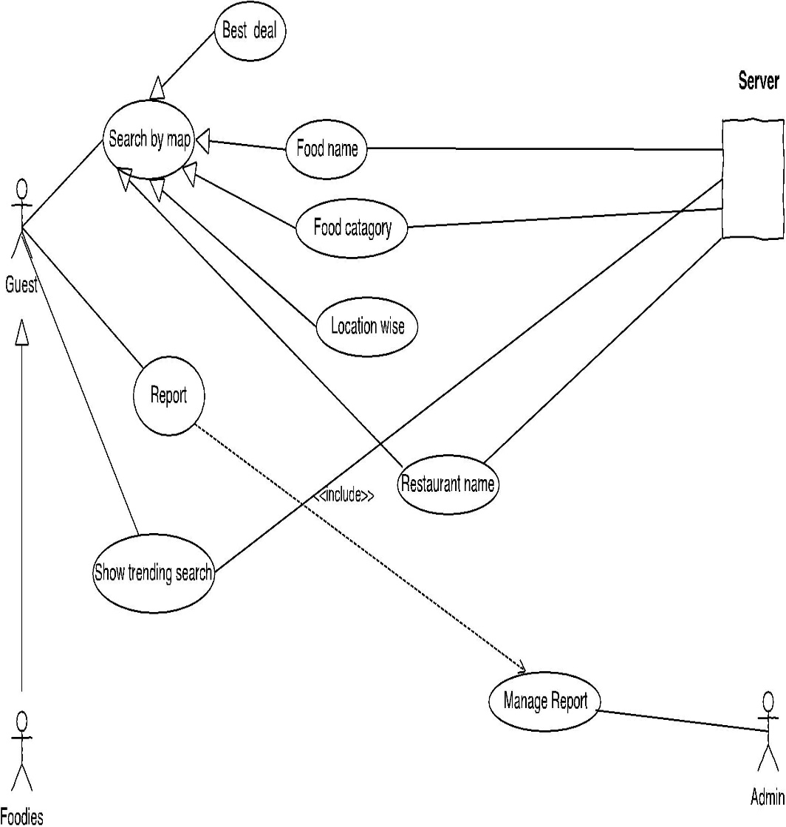

**Figure-1:** Use Case Diagram for Guest

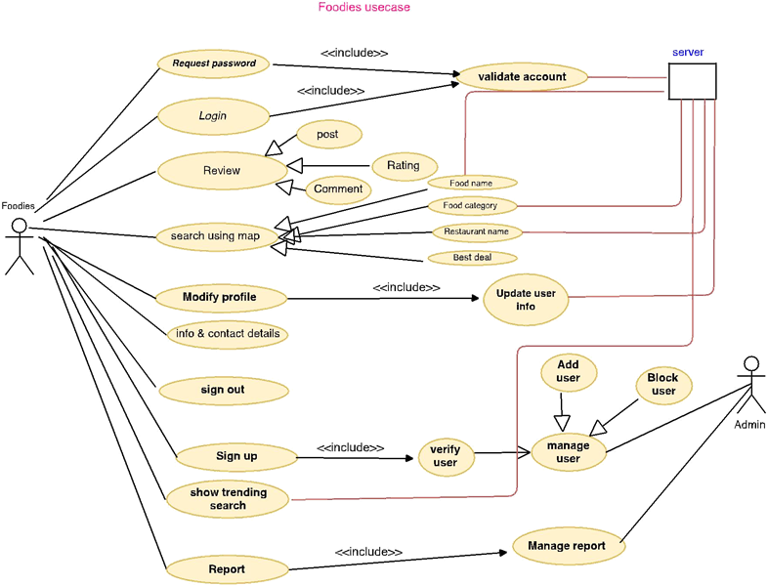

**Figure-2:** Use Case Diagram for Foodies

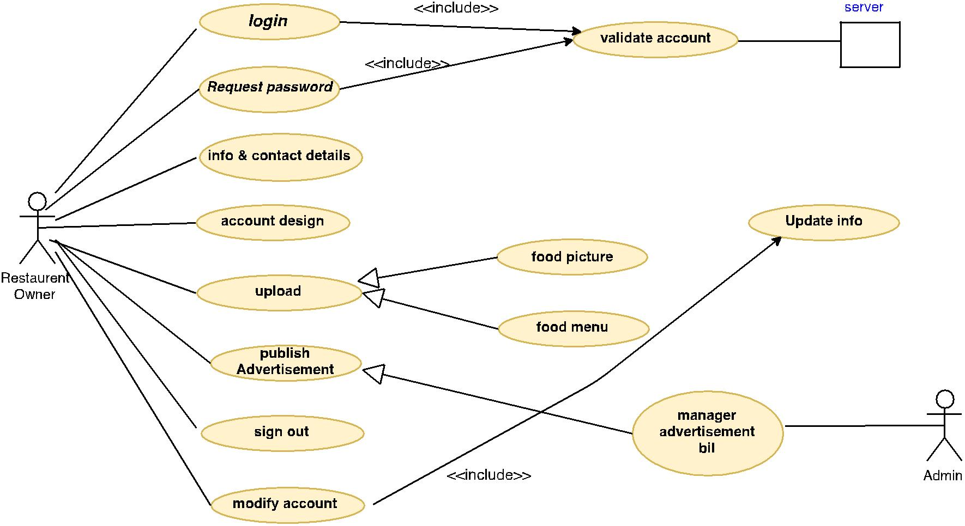

**Figure-3:** Use Case Diagram for Restaurant owner

**4.2.2 Activity Diagrams**

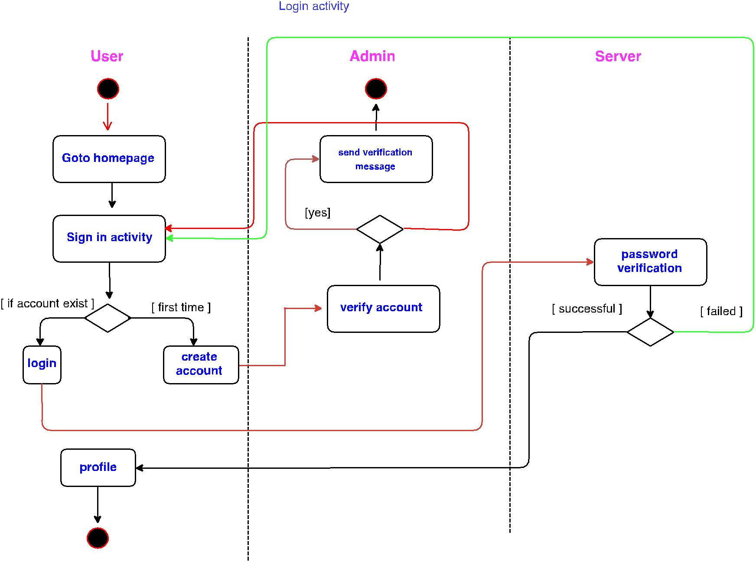

**Figure – 4:** Login Activity

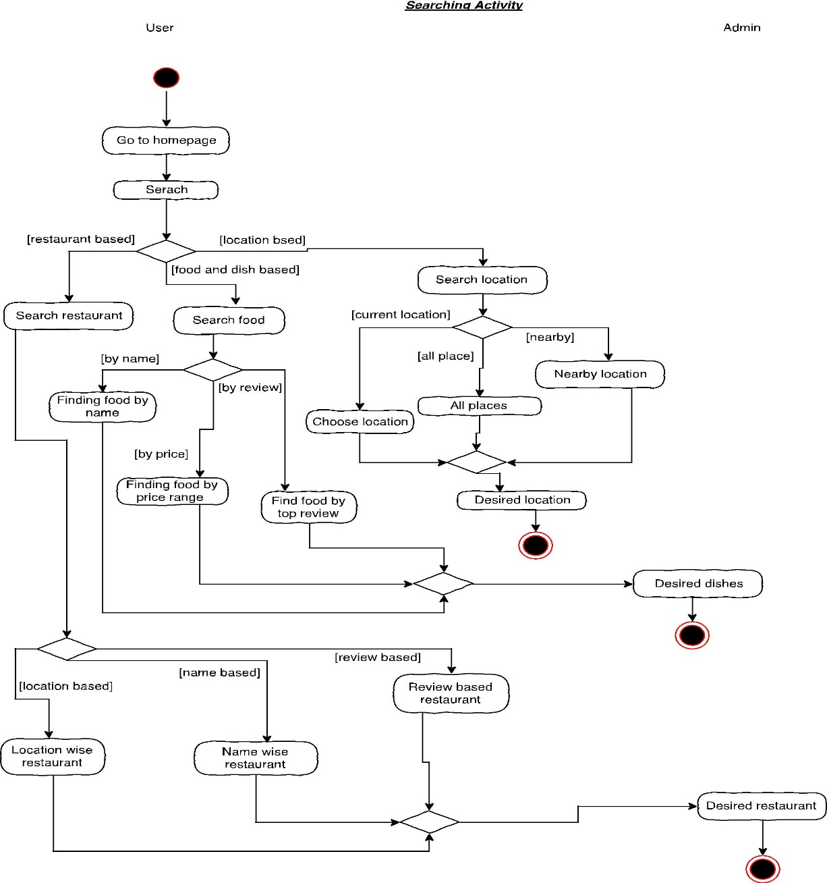

**Figure – 5:** Searching Activity

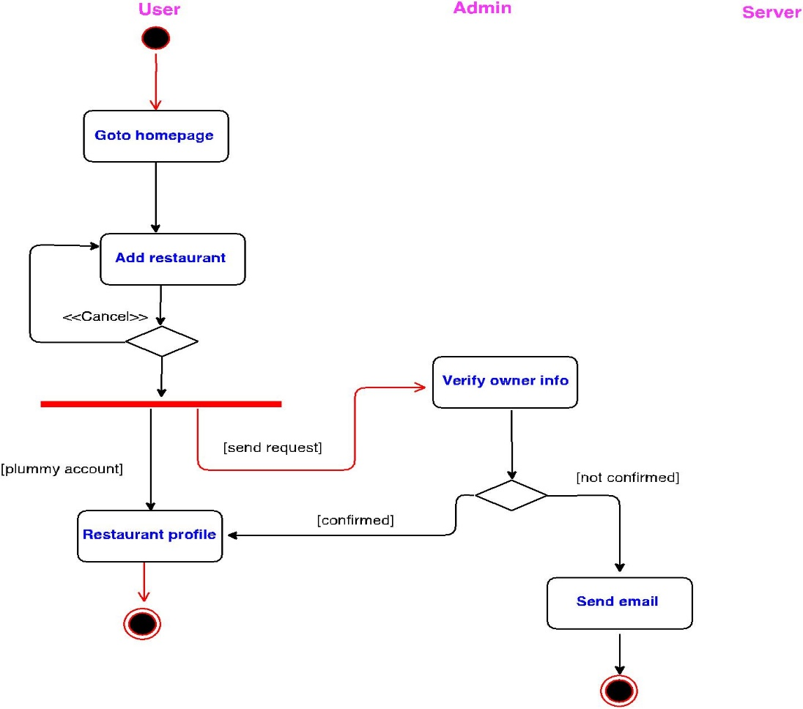

**Figure – 6:** Restaurant Account Approval Activity

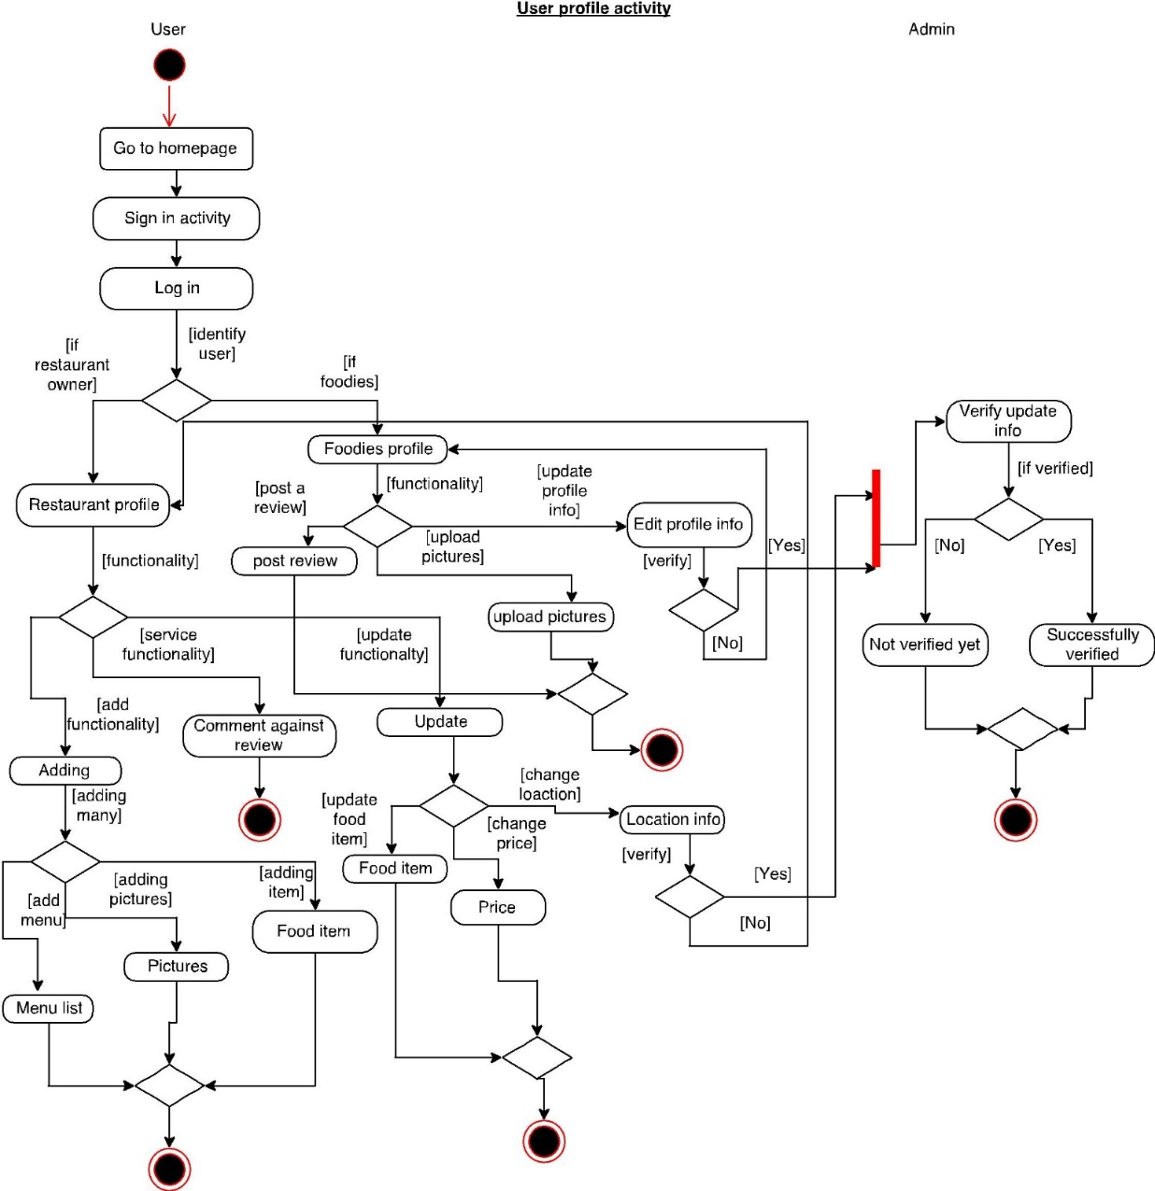

**Figure – 7:** User Profile Activity

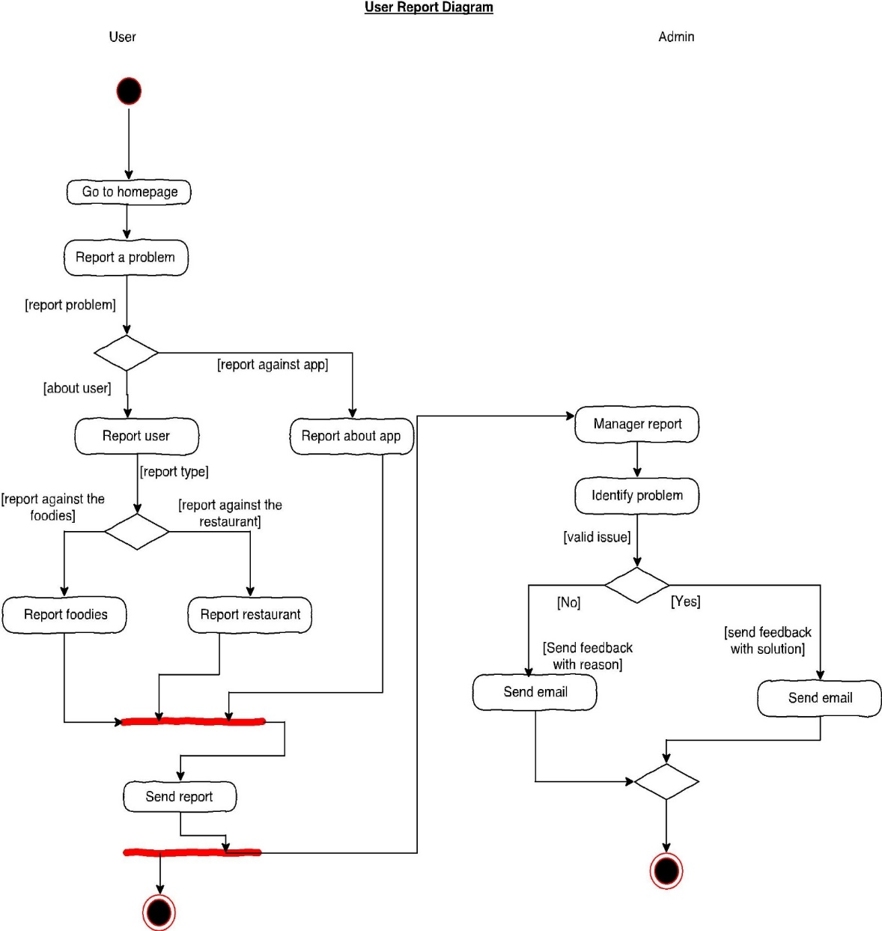

**Figure – 8:** User Report Activity

**4.2.3 Entity Relation Diagram**

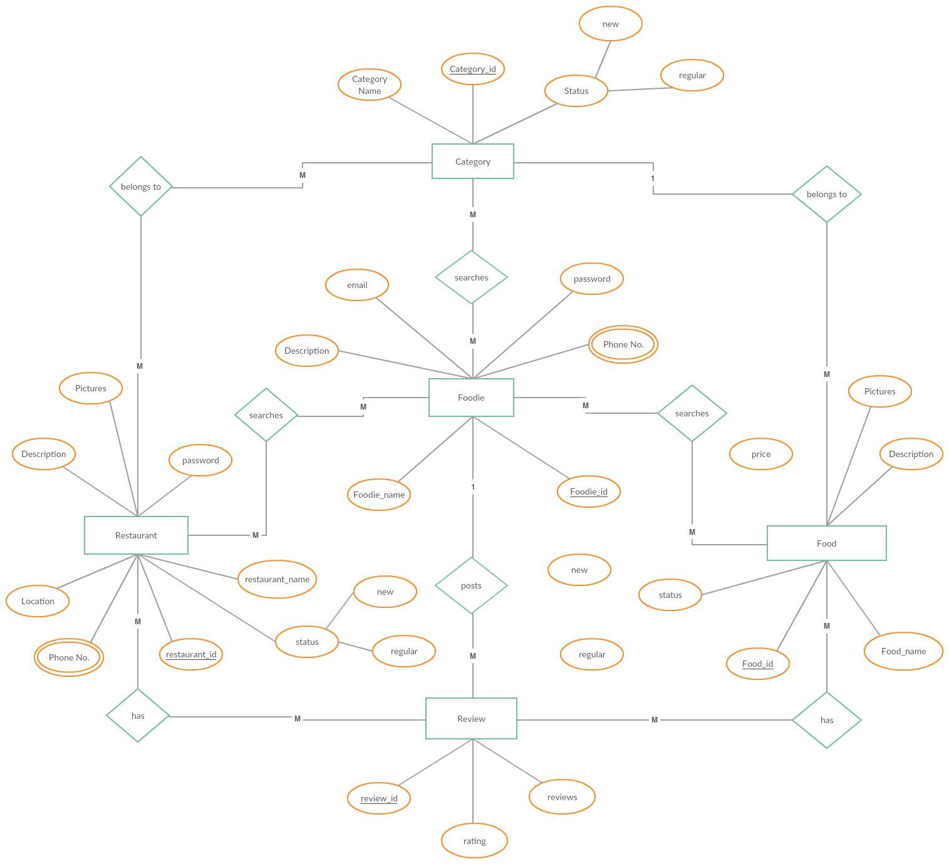

**Figure – 9:** ER diagram

**4.3 Data Dictionary**

**Table-5:** Image Gallery

|  |  |  |  |  |  |  |
| --- | --- | --- | --- | --- | --- | --- |
| **Database Table Name: Image Gallery** | | | | | | |
| **Column Name** | **DataType** | **Nullable** | **Default Value** | **Auto Increment** | **Key** | **Connected With** |
| Image_id | integer | no | No | Yes | Primary |  |
| Image | blob | no | No | no |  |  |
| RESTAURANT_ID | integer | no | No | no | Foreign | Table Restaurant Column Col1 |

**Table-6:** Restaurant

|  |  |  |  |  |  |  |
| --- | --- | --- | --- | --- | --- | --- |
| **Database Table Name: Restaurant** | | | | | | |
| **Column Name** | **DataType** | **Nullable** | **Default Value** | **Auto Increment** | **Key** | **Connected With** |
| RESTAURANT_ID | integer | no | No | Yes | Primary |  |
| RESTAURANT_NAME | Varchar (255) | no | No | no | Unique |  |
| RESTAURANT_EMAIL | Varchar (255) | no | No | no |  |  |
| RESTAURANT_PASSWORD | Varchar (255) | no | No | no |  |  |
| OWNER_TYPE | Varchar (255) | no | No | no |  |  |
| PHONE_NUMBER | integer | no | No | no |  |  |
| RESTAURANT_ADDRESS | Varchar (255) | no | No | no |  |  |
| ACCOUNT_STATUS | Varchar (255) | no | No | no |  |  |
| RESTAURANT_IMAGE | blob | no | yes | no |  |  |
| RESTAURANT_RATING | Double (8,2) | no | No | no |  |  |
| RESTAURANT_STATUS | Varchar (10) | no | No | no |  |  |
| OPEN_TIME | Varchar (20) | no | No | no |  |  |
| CLOSE_TIME | Varchar (20) | no | No | no |  |  |
| TYPE | Varchar (255) | no | yes | no |  |  |

**Table-7:** Cuisine

|  |  |  |  |  |  |  |
| --- | --- | --- | --- | --- | --- | --- |
| **Database Table Name: cuisine** | | | | | | |
| **Column Name** | **DataType** | **Nullable** | **Default Value** | **Auto Increment** | **Key** | **Connected With** |
| cuisine_id | Integer | no | No | Yes | Primary |  |
| cuisine_name | Varchar(20) | no | Yes | no |  |  |
| Type | Varchar(255) | no | Yes | no |  |  |

**Table-8:** Selected cuisine

|  |  |  |  |  |  |  |
| --- | --- | --- | --- | --- | --- | --- |
| **Database Table Name:** selected_cuisine | | | | | | |
| **Column Name** | **DataType** | **Nullable** | **Default Value** | **Auto Increment** | **Key** | **Connected With** |
| cuisine_id | integer | no | No | Yes | Primary |  |
| cuisine_name | Varchar (20) | no | no | no | Foreign | Table cuisine Column Col2 |
| RESTAURANT_ID | integer | no | no | no | Foreign | Table Restaurant Column Col1 |

**Table-9:** Users

|  |  |  |  |  |  |  |
| --- | --- | --- | --- | --- | --- | --- |
| **Database Table Name:** users | | | | | | |
| **Column Name** | **DataType** | **Nullable** | **Default Value** | **Auto Increment** | **Key** | **Connected With** |
| _user_id | integer | no | no | Yes | Primary |  |
| user_email | Varchar(255) | no | no | no | unique |  |
| user_password | Varchar(255) | no | no | no |  |  |
| user_type | Varchar(50) | no | no | no |  |  |

**Table-10:** Food

|  |  |  |  |  |  |  |
| --- | --- | --- | --- | --- | --- | --- |
| **Database Table Name:** food | | | | | | |
| **Column Name** | **DataType** | **Nullable** | **Default Value** | **Auto Increment** | **Key** | **Connected With** |
| food_id | Integer | No | no | Yes | Primary |  |
| food_name | Varchar(100) | No | no | No |  |  |
| food_price | Double(5,2) | No | no | No |  |  |
| food_rating | Double(5,2) | No | yes | No |  |  |
| food_desc | Varchar(200) | No | no | No |  |  |
| cuisine_id | Integer | no | no | No | Foreign | Table selected_cuisine Column Col1 |
| Type | Varchar(255) | no | yes | No |  |  |

**Table-11:** Review table

|  |  |  |  |  |  |  |
| --- | --- | --- | --- | --- | --- | --- |
| **Database Table Name:** review**_**table | | | | | | |
| **Column Name** | **DataType** | **Nullable** | **Default Value** | **Auto Increment** | **Key** | **Connected With** |
| review_id | Integer | no | no | Yes | Primary |  |
| reviewer_name | Varchar(255) | no | no |  |  |  |
| review | Varchar(255) | no | no |  |  |  |
| rating_number | Double(5,2) | no | no |  | Foreign | Table rating_table Column Col2 |
| rating_id | Integer | no | no |  | Foreign | Table rating_table Column Col1 |

**Table-12:** Rating table

|  |  |  |  |  |  |  |
| --- | --- | --- | --- | --- | --- | --- |
| **Database Table Name:** rating_table | | | | | | |
| **Column Name** | **DataType** | **Nullable** | **Default Value** | **Auto Increment** | **Key** | **Connected With** |
| rating_id | Integer | no | no | Yes | Primary |  |
| rating_number | Double (5,2) | no | no | no |  |  |
| _foodies_id | integer | no | no | no | Foreign | Table food Column Col1 |
| RESTAURANT_ID | integer | no | no | no | Foreign | Table Restaurant Column Col1 |

|  |  |  |  |  |  |  |
| --- | --- | --- | --- | --- | --- | --- |
| **Database Table Name:** foodies | | | | | | |
| **Column Name** | **DataType** | **Nullable** | **Default Value** | **Auto Increment** | **Key** | **Connected With** |
| _foodies_id | integer | no | No | Yes | Primary |  |
| foodies_name | Varchar(255) | no | No | no |  |  |
| foodies_email | Varchar(255) | no | No | no | unique |  |
| foodies_password | Varchar(50) | no | No | no |  |  |
| foodies_phone_number | integer | no | No | no |  |  |

**Table-13:** Foodies

**Table-14:** Food Rating Table

|  |  |  |  |  |  |  |
| --- | --- | --- | --- | --- | --- | --- |
| **Database Table Name: food_rating_table** | | | | | | |
| **Column Name** | **DataType** | **Nullable** | **Default Value** | **Auto Increment** | **Key** | **Connected With** |
| food_rating_id | integer | No | no | Yes | Primary |  |
| food_id | integer | No | no |  | Foreign | Table food Column Col1 |
| cuisine_id | integer | No | no |  | Foreign | Table selected_cuisine Column Col1 |
| RESTAURANT_ID | integer | No | no |  | Foreign | Table Restaurant Column Col1 |
| food_rating | Double(5,2) | No | no |  | Foreign | Table food Column Col4 |

**4.4 User Interface Design**

Followings are images of some of our interfaces for this application:



**Figure – 10:** App Launcher



**Figure – 11:** Map Activity



**Figure – 12:** Login Form

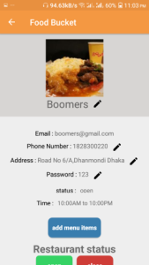

**Figure – 13:** Restaurant dashboard

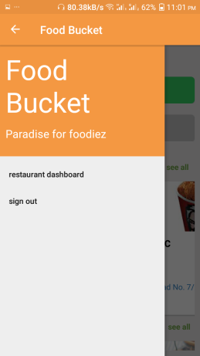

**Figure – 15:** Navigation drawer for restaurant owner after login

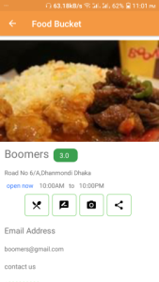

**Figure – 14:** Restaurant View Profile



**Figure – 17:** All cuisines with total restaurant

**Figure – 16:** Searching fields



**Figure – 19:** Photo gallery (restaurant)

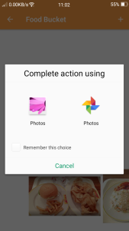

**Figure – 18:** Uploading picture for restaurants

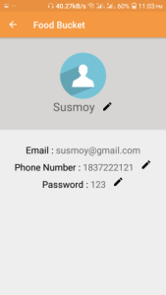

**Figure – 21:** Foodies profile

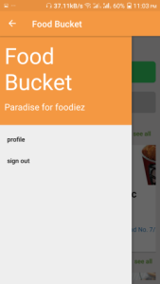

**Figure – 20:** Navigation drawer for foodies after login

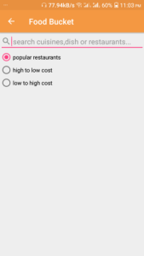

**Figure – 23:** Searching utilities

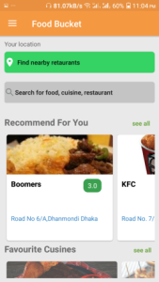

**Figure – 22:** Apps front view

|  |
| --- |
| **CHAPTER 5** |
| **FEATURE IMPLEMENTATIONS** |

**5.1 Sign Up**

Required for: restaurant owner, foodies

Description: A user need to sign up in the software to get all the facilities. So the user must give user name, email and password to create account.

Priority: High

Functional Requirements: System shall create a new account.

**5.2 Login**

Required for: restaurant owner, foodies

Description: Given that a user is registered he/she can login or get access to the server using email and password or directly using Facebook, Google plus.

Priority: High

Functional Requirements: System shall allow the user to use the account.

**5.3 Change Password**

Required for: restaurant owner, foodies

Description: If a user wants to change his/her password then the user will be able to request for a new password.

Priority: High

Functional Requirements: System shall send a view to access the user to change their password in their account.

**5.4 Set Information**

Required for: restaurant owner, foodies

Description: Users have to set their important information about themselves including phone numbers, emails.

Priority: High

Functional Requirements: System shall store all the important user data in order to give information to the profile.

**5.5 Search Method Selection**

Required for: guest user, restaurant owner, foodies

Description: Users can set the method of search. They just have to set how they want the search to be executed.

Priority: High

Functional Requirements: System will search according to user’s choice and return the results.

**5.6 Modify Search**

Required for: guest user, restaurant owner, foodies

Description: Users will be able to modify their search whenever they want like if they want to filter their search by price, rating they can do it too.

Priority: Medium

Functional Requirements: System shall update the information if users wants to modify the search.

**5.7 Show Reviews**

Required for: guest user

Description: Users will be able to see the reviews of other’s post.

Priority: Medium

Functional Requirements: System shall show reviews of users.

**5.8 Show and post Reviews**

Required for: foodies

Description: Users will be able to see the reviews of other’s post and also can post review.

Priority: Medium

Functional Requirements: System shall show reviews of users.

**5.9 Live Support**

Required for: foodies, guest user

Description: Users can have live support whenever they want as it will be available most of the time.

Priority: High

Functional Requirements: System shall provide live support so that users will find help if they are facing any problems if they have any harass issues.

**5.10 Select Search Location**

Required for: guest user, foodies

Description: Users can search from their current location or can select a certain location to see the best foods and reviews around the location.

Priority: High

Functional Requirements: System shall display all the reviews and foods of selected locations whenever user search from a certain location.

**5.11 Assign Own Food Rating**

Required for: foodies

Description: Users can give a rating of any food from any restaurants.

Priority: High

Functional Requirements: System shall assign the review of users to the database. And after assigning it will be visible to others.

**5.12 Cuisines selection for restaurants**

Required for: restaurant owner

Description: Restaurant owners can select their desired cuisines from apps recommended cuisines

Functional Requirements: System shall provide the recommended cuisines to restaurant owner for selecting cuisines.

**5.13 Modifying Account Information**

Required for: restaurant owner, foodies

Description: Users or Restaurant owners can make changes to their information or address or contact number.

Priority: Medium

Functional Requirements: System shall update the information when user makes an information change request.

**5.14 View Restaurant Information**

Required for: guest user, restaurant owner, foodies

Description: Users shall able to see restaurant information provided by restaurant owner.

Priority: High

Functional Requirements: System shall display all the information provided by restaurant owner.

**5.15 Remove Account**

Required for: admin

Description: Users or restaurant owner can cancel their account anytime.

Priority: Medium

Functional Requirements: System shall remove the account from the system database but a phone verification will be required.

**5.16 Uploading Pictures of Foods**

Required for: restaurant owner, foodies

Description: Users can see the photos from restaurants profile gallery.

Priority: high

Functional Requirements: System shall show the picture of restaurants.

**5.17 Delete cuisines**

Required for: restaurant owner

Description: restaurant owner can be able to delete their selected cuisines.

Priority: high

Functional Requirements: System shall share other reviewer’s review.

**5.18 entering food item with name price and description**

Required for: restaurant owner

Description: restaurant owner can insert food item name price and details.

Priority: high

Functional Requirements: System shall allow the comments in other reviewer’s review.

**5.19 One Tap Best Food Search**

Required for: guest user, foodies, restaurant owner

Description: Users can tap the one tap best food search button to find the best food around with lowest price, highest price, highest rating and lowest rating.

Priority: Medium

Functional Requirements: System shall take the current location and find the best food around.

**5.20 Sort by Price**

Required for: foodies, guest user

Description: Users will be able to find the foods by sorting their price.

Priority: Medium

Functional Requirements: System shall sort the foods by price and return the results to users.

**5.21 Sort by Restaurant Rating**

Required for: foodies, guest user

Description: Users will be able to find the restaurants by sorting their rating.

Priority: Medium

Functional Requirements: System shall sort the foods by rating and return the results to users.

**5.22 Sort by Food Rating**

Required for: foodies, guest user

Description: Users will be able to find the foods by sorting their rating.

Priority: Medium

Functional Requirements: System shall sort the foods by rating and return the results to users.

**5.23 Sort by food price**

Required for: foodies, guest user

Description: Users will be able to find the foods by sorting their price range like low to high and high to low.

Priority: Medium

Functional Requirements: System shall sort the foods by rating and return the results to users.

**5.24 Update food name, price and description**

Required for: restaurant owner

Description: restaurant owner can update food item name, price and details.

Priority: Medium

Functional Requirements: System shall put reports to admins and they will verify and take preliminary actions.

**5.25 User and restaurant owner can sign out**

Required for: restaurant owner, foodies

Description: Users and restaurant owners will be able to sign out from the system.

Priority: Medium

Functional Requirements: System shall let the user to sign out.

|  |
| --- |
| **CHAPTER 6** |
| **SOFTWARE TESTING PLAN** |

Project name is FOOD BUCKET and works on Android application. We are using three types of testing. They are:

* System testing
* Regression testing
* User Acceptance testing.

**6.1 System Testing**

We tested to the program by system testing to find the defects and noted severity of defects, summary of defects and commented on them. System testing is the testing of a complete and fully integrated software product. System tests the overall system operations as a whole, typically from a customer’s perspective. System testing presumes that all components have been previously, successfully, integrated. System testing is done after integration testing is complete. System testing main focus is to verify that the customer requirements are fulfilled. System testing should test functional and non-functional requirements of the software. System testing is black-box testing and often done by independent testers.

**Table-15: System testing**

|  |  |  |  |  |  |
| --- | --- | --- | --- | --- | --- |
| **Test Case ID** | **Test Case** | **Tester** | **Severity of Defect** | **Summary of Defect** | **Comments** |
| 1 | Application Icon | Hasan | none | none | none |
| 2 | Navigation Bar work | Hasan | none | none | none |
| 3 | Find nearby location work properly | Hasan | none | none | none |
| 4 | Display current location | Hasan | none | none | none |
| 5 | Search by location work | Hasan | none | none | none |
| 6 | Display nearby restaurants | Hasan | High | Stays in the find nearby location page | Not working |
| 7 | Click on Search cuisines, dish or restaurants | Hasan | none | none | none |
| 8 | Show suggestions | Hasan | none | none | none |
| 9 | Display categories | Hasan | none | none | none |
| 10 | Display Popularity | Hasan | none | none | none |
| 11 | Press high to low radio button | Hasan | none | none | none |
| 12 | Press low to high radio button | Hasan | none | none | none |
| 13 | Display Recommendation | Hasan | none | none | none |
| 14 | Click on restaurants Card view | Hasan | none | none | none |
| 15 | Make call button work properly | Hasan | none | none | none |
| 16 | Location tracking | Hasan | medium | Stays in the restaurant page | Not working properly |
| 17 | Display Food menu button | Hasan | none | none | none |
| 18 | Display cuisines working | Hasan | none | none | none |
| 19 | Display Food rating | Hasan | medium | Stays in the restaurant page | After login give food rate |
| 20 | Display review button work | Hasan | none | none | none |
| 21 | Show all reviews | Hasan | none | none | none |
| 22 | Show my reviews | Hasan | none | none | none |
| 23 | Display gallery icon button work | Hasan | none | none | none |
| 24 | Click on add pictures button work | Hasan | none | none | none |
| 25 | Click on take photo button work | Hasan | none | none | none |
| 26 | Choose photo is not working without login | Hasan | none | none | none |
| 27 | Show Share icon work | Hasan | none | none | none |
| 28 | Share using | Hasan | Medium | Redirect on 27 no test case | Under construction |
| 29 | Without login cannot give rating | Hasan | none | none | none |
| 30 | Without login cannot give writing about | Hasan | none | none | none |
| 31 | Click on Favorite Cuisines | Hasan | none | none | none |
| 32 | Click on Cuisines name within existing restaurants | Hasan | none | none | No need |
| 33 | Display Restaurants list | Hasan | none | none | none |
| 34 | Display Top rated restaurants | Hasan | none | none | none |
| 35 | Display Top rated restaurants list | Hasan | none | none | none |
| 36 | Display Newly open restaurants | Hasan | none | none | none |
| 37 | Display Newly open restaurants list | Hasan | none | none | none |
| 38 | Display login required button | Hasan | none | none | none |
| 39 | Press login button work | Hasan | none | none | none |
| 40 | Press join here button | Hasan | none | none | none |
| 41 | Properly show  Email: text field | Hasan | none | none | none |
| 42 | Properly show  Username: text field | Hasan | none | none | none |
| 43 | Properly show  Password: text field | Hasan | none | none | none |
| 44 | Properly show  Phone number: text field | Hasan | none | none | none |
| 45 | Give phone number | Hasan | High | Don’t show error message | Country phone code is not working |
| 46 | Email verification | Hasan | none | none | none |
| 47 | Sign up button is not working without fill up the requirements | Hasan | none | none | none |
| 48 | Sign up button work | Hasan | none | none | none |
| 49 | Click on Learn more button work properly | Hasan | none | none | none |
| 50 | Properly show  Email: text field | Hasan | none | none | none |
| 51 | Properly show  password: text field | Hasan | none | none | none |
| 52 | Email and password text field is blank then show error message | Hasan | none | none | none |
| 53 | Email text field is blank then show error message | Hasan | none | none | none |
| 54 | Password text field is blank then show error message | Hasan | none | none | none |
| 55 | If Email text field is not fill up and give password then show error message | Hasan | none | none | none |
| 56 | Give invalid email and password then pressed on sign in button show error message | Hasan | none | none | none |
| 57 | Give valid email and password then pressed on sign in button | Hasan | none | none | None |
| 58 | With login give food rating | Hasan | none | none | None |
| 59 | With login search cuisines, dish or restaurants | Hasan | none | none | None |
| 60 | With login find nearby restaurants work | Hasan | none | none | None |
| 61 | With login display current location | Hasan | none | none | None |
| 62 | With login show nearby restaurants | Hasan | High | Stays in the 61 no test case | Not working |
| 63 | Rate this place | Hasan | none | none | none |
| 64 | Give review | Hasan | none | none | none |
| 65 | With login give my review | Hasan | none | none | none |
| 66 | With login choose photo | Hasan | none | none | none |
| 67 | Give multiple review and rating in a restaurant | Hasan | none | none | none |
| 68 | Press back button | Hasan | none | none | none |
| 69 | Display Dashboard button | Hasan | none | none | none |
| 70 | Press Dashboard button | Hasan | none | none | none |
| 71 | Editing username | Hasan | none | none | none |
| 72 | Editing phone number | Hasan | none | none | none |
| 73 | Editing password | Hasan | none | none | none |
| 74 | Edit after press edit button | Hasan | none | none | none |
| 75 | Press back button | Hasan | none | none | none |
| 76 | Display Sign out button | Hasan | none | none | none |
| 77 | Click on sign out button work properly | Hasan | none | none | none |
| 78 | Display add a place button | Hasan | none | none | none |
| 79 | Click on add a place button | Hasan | none | none | none |
| 80 | Display restaurant name text field properly | Hasan | none | none | none |
| 81 | Display email text field properly | Hasan | none | none | none |
| 82 | Display address text field properly | Hasan | none | none | none |
| 83 | Display password text field properly | Hasan | none | none | none |
| 84 | Display Address text area properly | Hasan | none | none | none |
| 85 | Display restaurant owner or manager radio button properly | Hasan | none | none | none |
| 86 | Without fill up restaurants information click on submit button show error message | Hasan | none | none | none |
| 87 | Give invalid email show error message | Hasan | none | none | none |
| 88 | All text field fill up restaurants information then click on submit button work | Hasan | none | none | none |
| 89 | Display additional request | Hasan | none | none | none |
| 90 | Display Dashboard button and press this button work | Hasan | none | none | none |
| 91 | Editing restaurant name to edit button work properly | Hasan | none | none | none |
| 92 | Upload or update restaurant profile image | Hasan | none | none | none |
| 93 | Update phone number | Hasan | none | none | none |
| 94 | Update Restaurant address | Hasan | none | none | none |
| 95 | Update password | Hasan | none | none | none |
| 96 | Click on add menu item icon | Hasan | none | none | none |
| 97 | Click after selected cuisine button | Hasan | none | none | none |
| 98 | Restaurant owner/manager can select different cuisine | Hasan | none | none | none |
| 99 | Click on individual item from selected cuisine list | Hasan | none | none | none |
| 100 | New food item update | Hasan | none | none | none |
| 101 | Delete food item | Hasan | none | none | none |
| 102 | Click on open button in restaurants status | Hasan | none | none | none |
| 103 | Click on close button in restaurants status | Hasan | none | none | none |
| 104 | Without filling up opening time & closing time click on save time button not update new time | Hasan | none | none | none |
| 105 | Only filling up opening time click on save time button | Hasan | none | none | none |
| 106 | Only filling up closing time click on save time button | Hasan | none | none | none |
| 107 | Owner/manager login search cuisine, dish or restaurants | Hasan | none | none | none |
| 107 | Owner/manager login show current location | Hasan | none | none | none |
| 108 | Add image when login own profile of restaurant Owner/manager | Hasan | none | none | none |
| 109 | Cannot add image when login own restaurant profile of Owner/manager | Hasan | none | none | none |
| 110 | Click on restaurant rating from a restaurant logged in account | Hasan | none | none | none |
| 111 | Click on restaurant review from a restaurant logged in account | Hasan | none | none | none |
| 112 | Login own account of restaurant owner/manager can make call of other restaurants | Hasan | none | none | none |
| 113 | Login own account of restaurant owner/manager can check food menu of other restaurants | Hasan | none | none | none |
| 114 | Login own account of restaurant owner/manager display food item list under individual cuisine of other restaurants | Hasan | none | none | none |
| 115 | Login own account of restaurant owner/manager using share | Hasan | Medium | Could not work | Can’t share |
| 116 | Press Sign out button work | Hasan | none | none | none |
| 117 | Press back button giving option to user wants to exit or not | Hasan | none | none | none |
| 118 | Click yes button then exit | Hasan | none | none | none |
| 119 | Click no button then stay in food bucket application | Hasan | none | none | none |
| 120 | Password hidden icon work properly | Hasan | none | none | none |

**6.2 Regression Testing**

Regression tests determine that the system remains stable as it cycles through the integration of other subsystems and through maintenance tasks. Testing that is performed after making a functional improvement or repair to the program. Its purpose is to determine if the change has regressed other aspects of the program. In this category, new tests are not designed; instead, test cases are selected from the existing pool and executed. Finally we tested our project by an own user and write report and also found the defects.

The table below summarizes the test cases employed for regression testing and the test results obtained for each test case:

**Table-16: Regression testing**

|  |  |  |  |  |  |  |  |
| --- | --- | --- | --- | --- | --- | --- | --- |
| **Test Case ID** | **Date Tested** | **Tester** | **Pass /Fail** | **Severity of Defect** | **Summary of Defect** | **Closed prior to Production Release?** | **Comments** |
| 96 | 10/08/2018 | Hasan | Pass | High | Without filling up any requirement but add food item. | Yes | Problem  Solved. |
| 19 | 10/08/2018 | Hasan | Pass | Medium | Guest browser rated the food which is not in the requirement | Yes | Problem Solved |
| 45 | 10/08/18 | Hasan | Pass | High | Validation problem in foodies and restaurant owner/ manager give phone number | Yes | Problem solved |
| 121 | 10/08/18 | Hasan | Pass | Medium | Now can delete the pictures | Yes | Problem solved |
| 73 | 11/08/18 | Hasan | Pass | Medium | Now give old password again then show error message and give new password then it will update | Yes | Problem solved |
| 58 | 11/08/18 | Hasan | Pass | Medium | Give food rating it will show big fractional number but now it not show those types of number | Yes | Problem solved |
| 63 | 11/08/18 | Hasan | Pass | Medium | Here is review but again give review then it will be added no show error message but now show error message | Yes | Problem solved |
| 64 | 11/08/18 | Hasan | Pass | Medium | Here is rating but again give review then it will be added no show error message | Yes | Problem solved |
| 122 | 11/08/18 | Hasan | Pass | Medium | As a restaurant owner registration a foodie same email but login can’t work now login as a foodies and also restaurant owner/ manager use same email | Yes | Problem solved |

**6.3 Acceptance Testing**

Acceptance testing is Formal testing for product evaluation. Formal testing conducted to determine whether a system satisfies its acceptance criteria. Performed by customers/end users (preferably). Verifies functionality and usability of the software. Conducted prior to software being released to live operation. At this level of testing, the software should be in a sufficiently defect-free state to permit the emphasis to change. Acceptance testing is usually the last step before the user/customer takes the possession of the software.

The table below summarizes the test cases employed for user acceptance testing and the test results obtained for each test case:

**Table-17: Acceptance testing**

|  |  |  |  |  |  |  |  |
| --- | --- | --- | --- | --- | --- | --- | --- |
| Test Case ID | Date Tested | Tester | Pass/  Fail | Severity of Defect | Summary of Defect | Closed prior to Production Release? | Comments |
| 1 | 11/08/18 | Hasan | Pass | none | none | Yes | none |
| 2 | 11/08/18 | Hasan | Pass | none | none | Yes | none |
| 3 | 11/08/18 | Hasan | Pass | none | none | Yes | none |
| 4 | 11/08/18 | Hasan | Pass | none | none | Yes | none |
| 5 | 11/08/18 | Hasan | Fail | high | Stays in the find nearby location page | Yes | Must be fixed 5 |
| 6 | 11/08/18 | Hasan | Pass | none | none | Yes | none |
| 7 | 11/08/18 | Hasan | Pass | none | none | Yes | none |
| 8 | 11/08/18 | Hasan | Pass | none | none | Yes | none |
| 9 | 11/08/18 | Hasan | Pass | none | none | Yes | none |
| 10 | 11/08/18 | Hasan | Pass | none | none | Yes | none |
| 11 | 11/08/18 | Hasan | Pass | none | none | Yes | none |
| 12 | 11/08/18 | Hasan | Pass | none | none | Yes | none |
| 13 | 11/08/18 | Hasan | Pass | none | none | Yes | none |
| 14 | 11/08/18 | Hasan | Pass | none | none | Yes | none |
| 15 | 11/08/18 | Hasan | Pass | none | none | Yes | none |
| 16 | 11/08/18 | Hasan | Fail | medium | Stays in the restaurant page | Yes | Must be fixed 16 |
| 17 | 11/08/18 | Hasan | Pass | none | none | Yes | none |
| 18 | 11/08/18 | Hasan | Pass | none | none | Yes | none |
| 19 | 11/08/18 | Hasan | Fail | medium | Stays in the restaurant page | Yes | Must be fixed 19 |
| 20 | 11/08/18 | Hasan | Pass | none | none | Yes | none |
| 21 | 11/08/18 | Hasan | Pass | none | none | Yes | none |
| 22 | 11/08/18 | Hasan | Pass | none | none | Yes | none |
| 23 | 11/08/18 | Hasan | Pass | none | none | Yes | none |
| 24 | 11/08/18 | Hasan | Pass | none | none | yes | none |
| 25 | 11/08/18 | Hasan | Pass | none | none | Yes | none |
| 26 | 11/08/18 | Hasan | Pass | none | none | Yes | none |
| 27 | 11/08/18 | Hasan | Pass | none | none | Yes | none |
| 28 | 11/08/18 | Hasan | Fail | medium | Redirect on 27 no test case | Yes | Must be fixed 28 |
| 29 | 11/08/18 | Hasan | Pass | none | none | Yes | none |
| 30 | 11/08/18 | Hasan | Pass | none | none | Yes | none |
| 31 | 11/08/18 | Hasan | Pass | none | none | Yes | none |
| 32 | 11/08/18 | Hasan | Pass | none | none | Yes | none |
| 33 | 11/08/18 | Hasan | Pass | none | none | Yes | none |
| 34 | 11/08/18 | Hasan | Pass | none | none | Yes | none |
| 35 | 11/08/18 | Hasan | Pass | none | none | Yes | none |
| 36 | 11/08/18 | Hasan | Pass | none | none | Yes | none |
| 37 | 11/08/18 | Hasan | Pass | none | none | Yes | none |
| 38 | 11/08/18 | Hasan | Pass | none | none | Yes | none |
| 39 | 11/08/18 | Hasan | Pass | none | none | Yes | none |
| 40 | 11/08/18 | Hasan | Pass | none | none | Yes | none |
| 41 | 11/08/18 | Hasan | Pass | none | none | Yes | none |
| 42 | 11/08/18 | Hasan | Pass | none | none | Yes | none |
| 43 | 11/08/18 | Hasan | Pass | none | none | Yes | none |
| 44 | 11/08/18 | Hasan | Pass | none | none | Yes | none |
| 45 | 11/08/18 | Hasan | Fail | high | Don’t show any error message | Yes | Must be fixed 45 |
| 46 | 11/08/18 | Hasan | Pass | none | none | Yes | none |
| 47 | 11/08/18 | Hasan | Pass | none | none | Yes | none |
| 48 | 11/08/18 | Hasan | Pass | none | none | Yes | none |
| 49 | 11/08/18 | Hasan | Pass | none | none | Yes | none |
| 50 | 11/08/18 | Hasan | Pass | none | none | Yes | none |
| 51 | 11/08/18 | Hasan | Pass | none | none | Yes | none |
| 52 | 11/08/18 | Hasan | Pass | none | none | Yes | none |
| 53 | 11/08/18 | Hasan | Pass | none | none | Yes | none |
| 54 | 11/08/18 | Hasan | Pass | none | none | Yes | none |
| 55 | 11/08/18 | Hasan | Pass | none | none | Yes | none |
| 56 | 11/08/18 | Hasan | Pass | none | none | Yes | none |
| 57 | 11/08/18 | Hasan | Pass | none | none | Yes | none |
| 58 | 11/08/18 | Hasan | Fail | medium | Rating in fractional | Yes | Does not Give proper rating |
| 59 | 11/08/18 | Hasan | Pass | none | none | Yes | none |
| 60 | 11/08/18 | Hasan | Pass | none | none | Yes | none |
| 61 | 11/08/18 | Hasan | Pass | none | none | Yes | none |
| 62 | 11/08/18 | Hasan | Fail | High | Stays in the 61 no test case | Yes | Must be fixed 62 |
| 63 | 11/08/18 | Hasan | Fail | medium | Here is review but again give review then it will be added no show error message | Yes | Don’t show any error message |
| 64 | 11/08/18 | Hasan | Pass | none | Here is rating but again give rating then it will be added no show error message | Yes | Don’t show any error message |
| 65 | 11/08/18 | Hasan | Pass | none | none | Yes | none |
| 66 | 11/08/18 | Hasan | Pass | none | none | Yes | none |
| 67 | 11/08/18 | Hasan | Pass | none | none | Yes | none |
| 68 | 11/08/18 | Hasan | Pass | none | none | Yes | none |
| 69 | 11/08/18 | Hasan | Pass | none | none | Yes | none |
| 70 | 11/08/18 | Hasan | Pass | none | none | Yes | none |
| 71 | 11/08/18 | Hasan | Pass | none | none | Yes | none |
| 72 | 11/08/18 | Hasan | Pass | none | none | Yes | none |
| 73 | 11/08/18 | Hasan | Fail | medium | Old password not convert new password | Yes | Password not update |
| 74 | 11/08/18 | Hasan | Pass | none | none | Yes | none |
| 75 | 11/08/18 | Hasan | Pass | none | none | Yes | none |
| 76 | 11/08/18 | Hasan | Pass | none | none | yes | none |
| 77 | 11/08/18 | Hasan | Pass | None | None | Yes | None |
| 78 | 11/08/18 | Hasan | Pass | None | None | Yes | None |
| 79 | 11/08/18 | Hasan | Pass | None | None | Yes | None |
| 80 | 11/08/18 | Hasan | Pass | None | None | Yes | None |
| 81 | 11/08/18 | Hasan | Pass | None | None | Yes | None |
| 82 | 11/08/18 | Hasan | Pass | None | None | Yes | None |
| 83 | 11/08/18 | Hasan | Pass | None | None | Yes | None |
| 84 | 11/08/18 | Hasan | Pass | None | None | Yes | None |
| 85 | 11/08/18 | Hasan | Pass | None | None | Yes | None |
| 86 | 11/08/18 | Hasan | Pass | None | None | Yes | None |
| 87 | 11/08/18 | Hasan | Pass | None | None | Yes | None |
| 88 | 11/08/18 | Hasan | Pass | None | None | Yes | None |
| 89 | 11/08/18 | Hasan | Pass | None | None | Yes | None |
| 90 | 11/08/18 | Hasan | Pass | None | None | Yes | None |
| 91 | 11/08/18 | Hasan | Pass | None | None | Yes | None |
| 92 | 11/08/18 | Hasan | Pass | None | None | Yes | None |
| 93 | 11/08/18 | Hasan | Pass | None | None | Yes | None |
| 94 | 11/08/18 | Hasan | Pass | None | None | Yes | None |
| 95 | 11/08/18 | Hasan | Pass | None | None | Yes | None |
| 96 | 11/08/18 | Hasan | Pass | None | None | Yes | None |
| 97 | 11/08/18 | Hasan | Pass | None | None | Yes | None |
| 98 | 11/08/18 | Hasan | Pass | None | None | Yes | None |
| 99 | 11/08/18 | Hasan | Pass | None | None | Yes | None |
| 100 | 11/08/18 | Hasan | Pass | None | None | Yes | None |
| 101 | 11/08/18 | Hasan | Pass | None | None | Yes | None |
| 102 | 11/08/18 | Hasan | Pass | None | None | Yes | None |
| 103 | 11/08/18 | Hasan | Pass | None | None | Yes | None |
| 104 | 11/08/18 | Hasan | Pass | None | None | Yes | None |
| 105 | 11/08/18 | Hasan | Pass | None | None | Yes | None |
| 106 | 11/08/18 | Hasan | Pass | None | None | Yes | None |
| 107 | 11/08/18 | Hasan | Pass | None | None | Yes | None |
| 108 | 11/08/18 | Hasan | Pass | None | None | Yes | None |
| 109 | 11/08/18 | Hasan | Pass | None | None | Yes | None |
| 110 | 11/08/18 | Hasan | Pass | None | None | Yes | None |
| 111 | 11/08/18 | Hasan | Pass | None | None | Yes | None |
| 112 | 11/08/18 | Hasan | Pass | None | None | Yes | None |
| 113 | 11/08/18 | Hasan | Pass | None | None | Yes | None |
| 114 | 11/08/18 | Hasan | Pass | None | None | Yes | None |
| 115 | 11/08/18 | Hasan | Pass | None | None | Yes | None |
| 116 | 11/08/18 | Hasan | Pass | None | None | Yes | None |
| 117 | 11/08/18 | Hasan | Pass | None | None | Yes | None |
| 118 | 11/08/18 | Hasan | Pass | None | None | Yes | None |
| 119 | 11/08/18 | Hasan | Pass | None | None | Yes | None |
| 120 | 11/08/18 | Hasan | Pass | None | None | Yes | None |

|  |
| --- |
| **CHAPTER 7** |
| **CONCLUSION** |

**7.1 Future Work**

The project is still at its basic stage with the additional multi-tenant advantage. There are more things that are already proposed while designing the database but still not released in first version. In future, we are expecting to work on Map and Food order system to our application along with solving some obvious bugs.

**7.2 Contribution to the Society**

Food is one of the basic human needs, but with an emphasis modern society puts on eating healthy, sophisticated and yet quickly restaurants are often the place to go when we need a bite. Restaurant search apps like Food Bucket which helps you to find out best places to eat nearby. User can search their desire food and they can also see the price of each food. In this way, many middle class people or students can go the restaurant between their budgets. This application also can detect user position and it will suggests nearest restaurant first.

|  |
| --- |
| **CHAPTER 8** |
| **REFERENCES** |

1. https://www.supermeal.pk/
2. https://www.thefork.com/
3. http://harriken.com/
4. https://foodmart.com.bd/
5. http://www.foodiez.com.bd/
6. http://www.hungrynaki.com/
7. https://www.foodpanda.com.bd/
8. https://www.zomato.com/kolkata
9. http://nc.foodspotting.com/find/in/The-World
10. https://www.openrice.com/en/hongkong
11. https://www.talabat.com/uae
12. https://cookups.com.bd/
13. https://www.yelp.com/